Open google docs

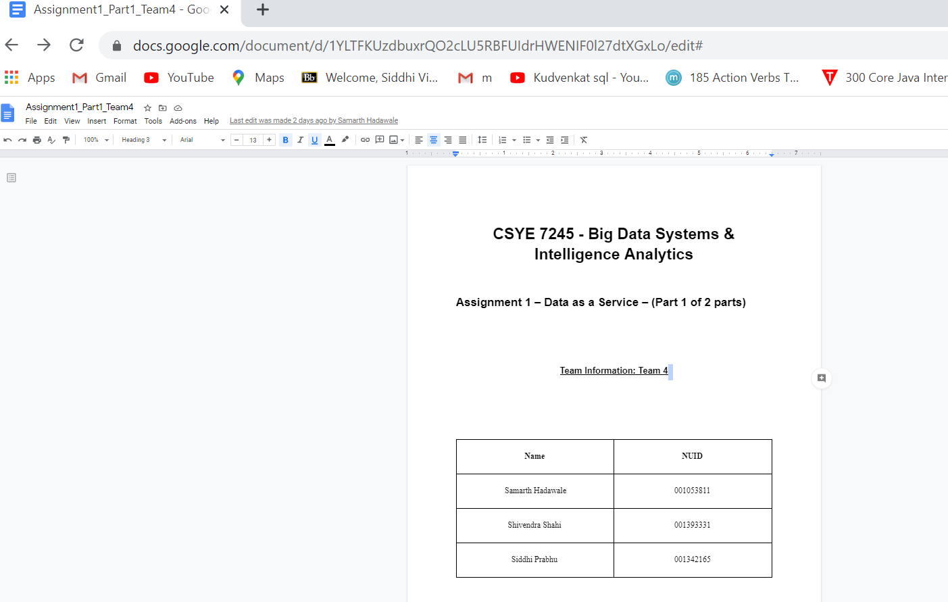

Navigate manually to [https://codelabs-preview.appspot.com/?file_id=[google-doc-id]](https://codelabs-preview.appspot.com/?file_id=%5Bgoogle-doc-id%5D)

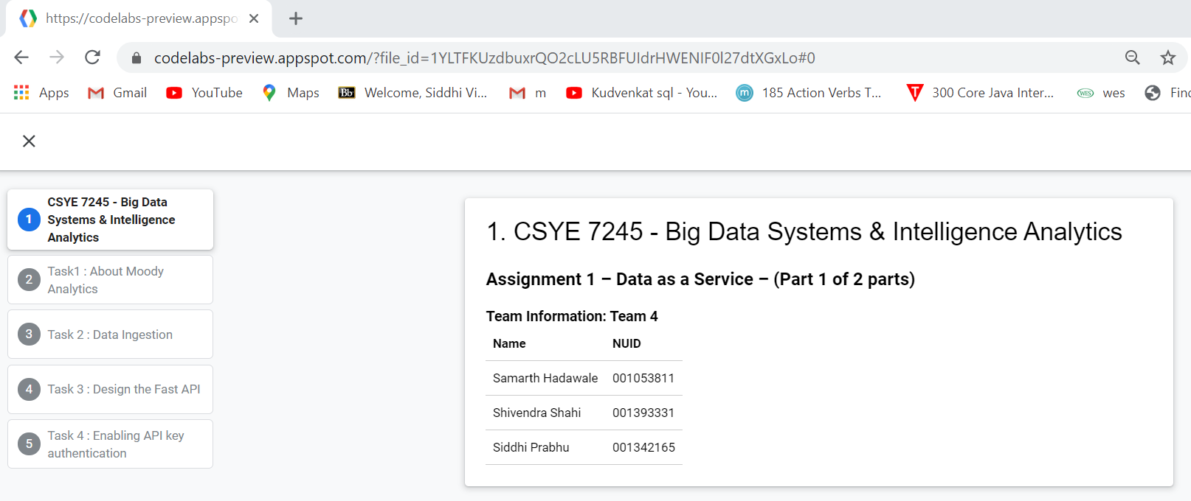

Add extension to chrome

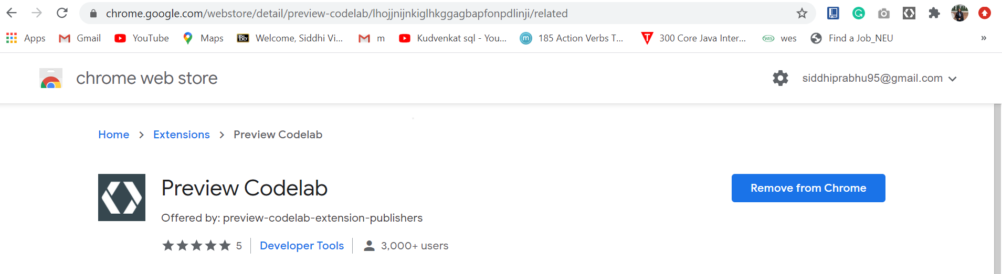

Navigate with preview code lab extension

